Diagnostic tool instruction

1. Preparation
2. DUT(board) plug I/O device, as Figure 1 .
3. Remote control.
4. USB storage
5. SD card
6. Necessary files

- product_type.txt (put on **USB storage** prior to start test)

- VIDEO0002.mp4 (put on **USB storage** prior to start test)

- 212.jpg(put on **SD card** prior to start test)

1. AP route ,set SSID to “AP001”, wifi encryption type =none.

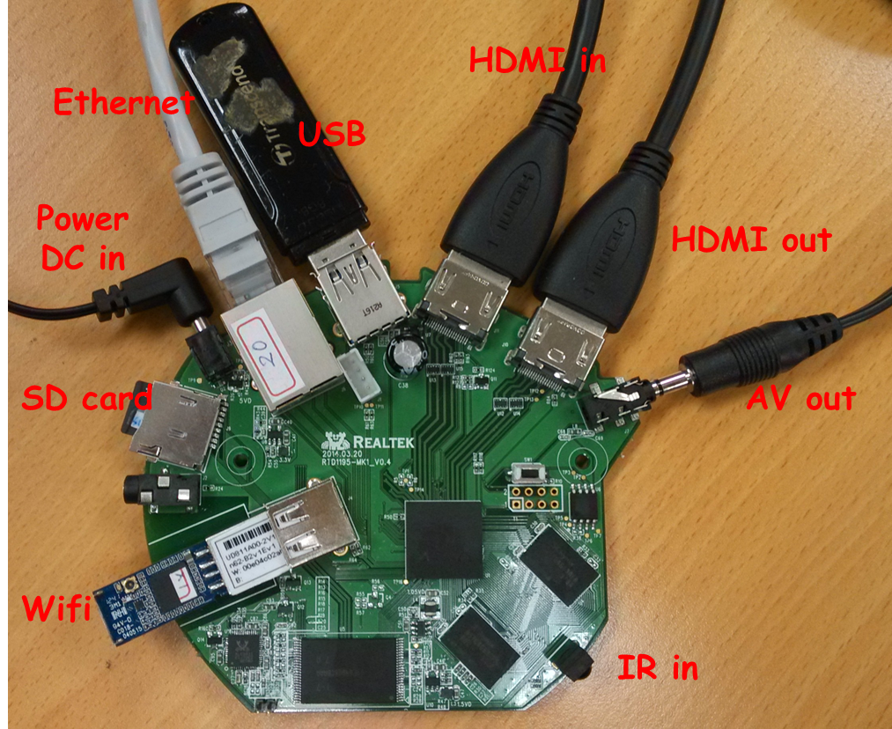

Figure 1

2.Power on ,In home menu (as Figure 2),long-press MEDIA_NEXT key on the remote control over 5 seconds to start Diagnostic tool .



Figure 2

3.Diagnostic tool has 4 test item ,each item can using button to trigger them ,at top-right corner is Product type that helps tester to recognize product is OTT or Dongle, if Product type is OTT ,the Ethernet test button is invisible ,as Figure 4.

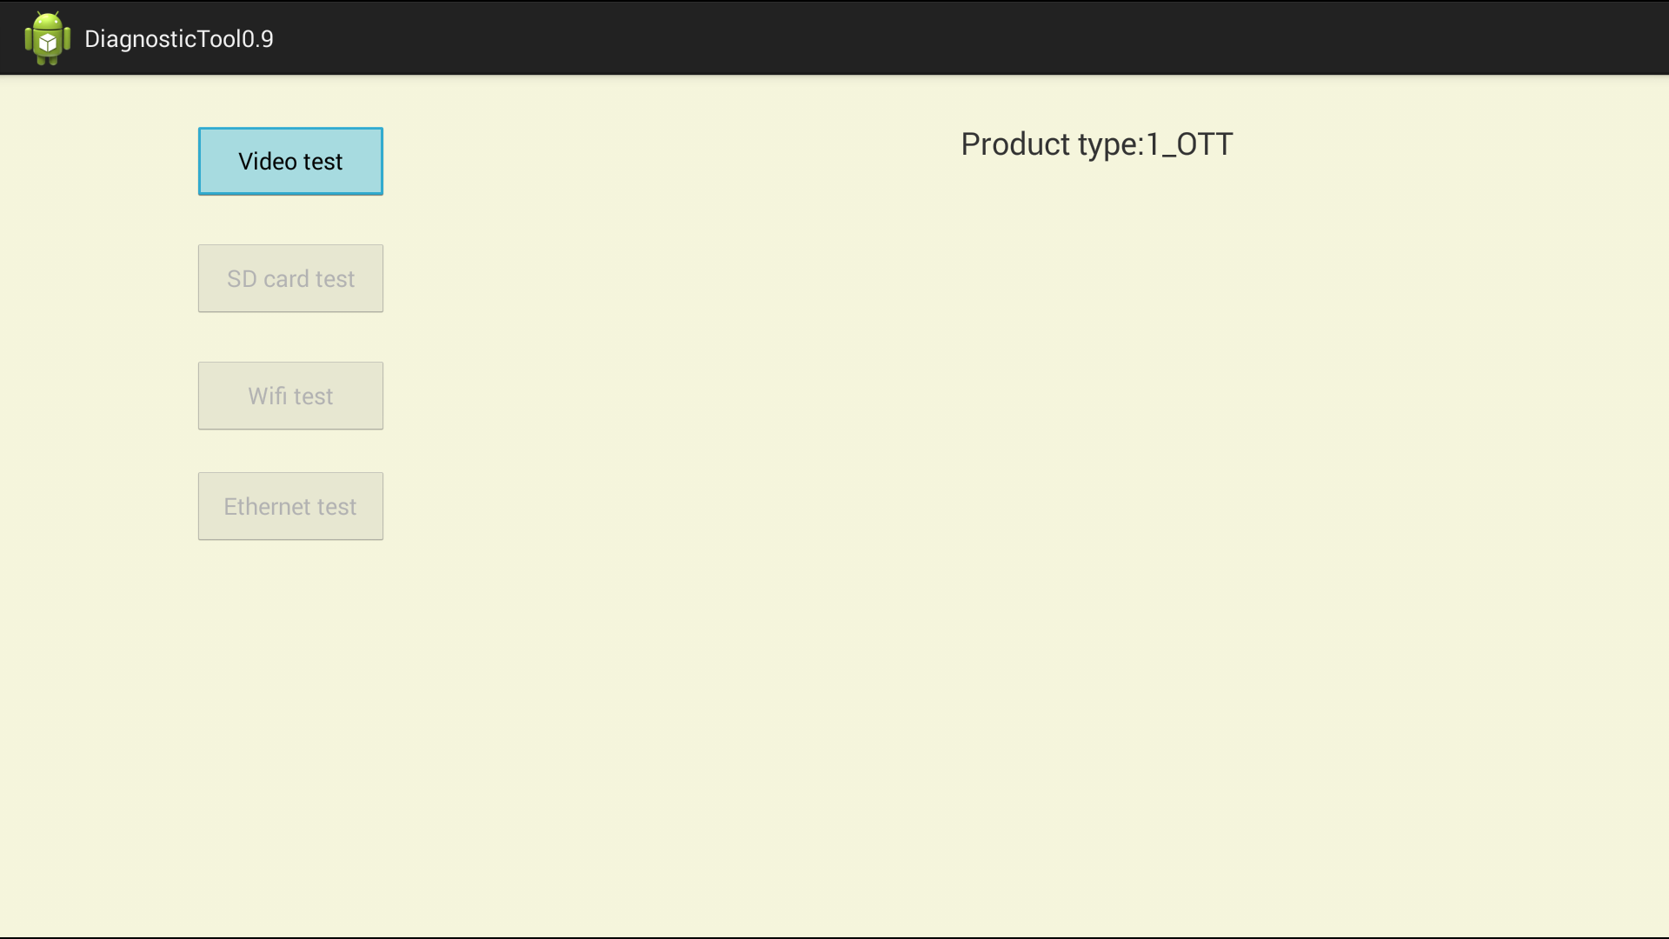

Figure 3

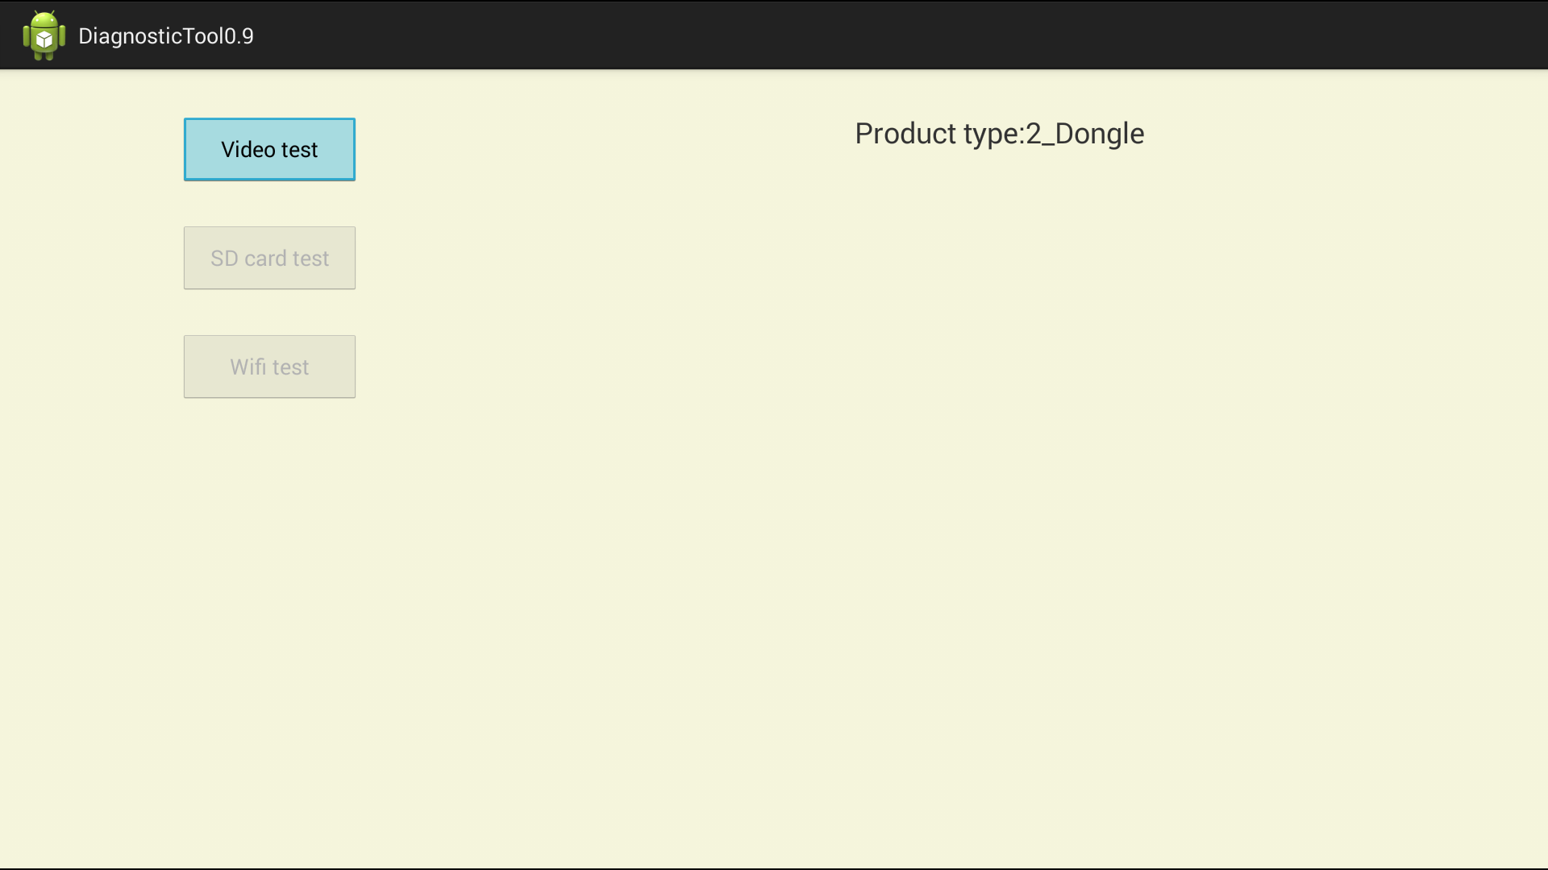

Figure 4

4.Test Flow (1)Video test ->(2)SD card test ->(3)Wifi test ->(4)Ethernet test.

1. Video test , play video clips ,after stop playback ,diagnostic tool will return .

The clips is read on /storage/sda1/VIDEO0002.mp4 ,test duration is depend on clips duration ,10~20 seconds is commanded.

1. SD Card test, render still picture, after showing picture ,press return key on remote control to exit .
2. Wifi test will set wifi on automatically and connect AP route naming as SSID “AP001”,at button right side display "wifi ip= x.x.x.x and AP Name: AP001.

as Figure 5.

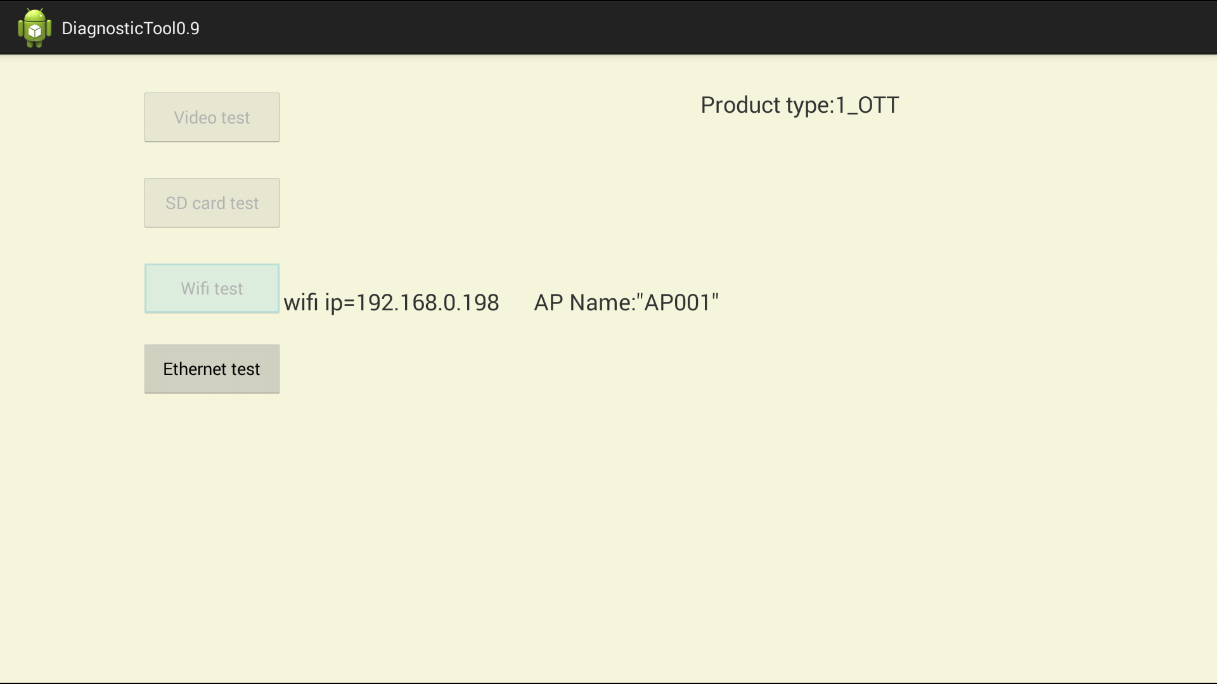

1. Ethernet test get the IP address assigned to Eth0 at button right side display eth ip=x.x.x.x.(Product type:2_Dongle no need to test),as Figure6

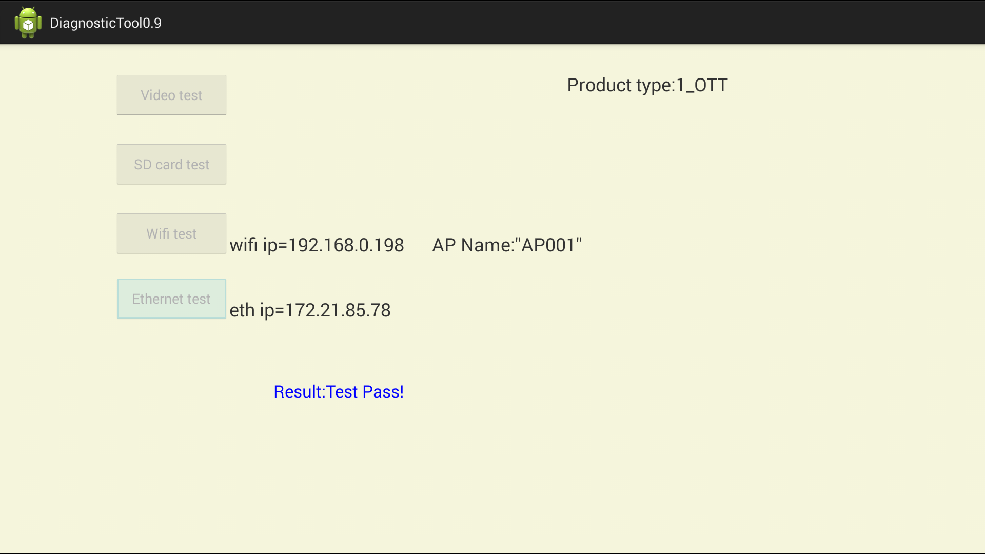

5. Test result

Part I : video test and SD Card test result distinguish by tester ,reference table 1.

Part II : Wifi and Ethernet test result show on the bottom of screen .

Result:Test Pass! or Result:Test fail!

Test criteria:

If any item test result fail, the DUT is fail.

|  |  |  |  |
| --- | --- | --- | --- |
|  |  | pass | fail |
| 1 | Video test | Play video ok. | Can’t play this video |
| 2 | SD Card test | Render still picture ok. | Black screen |
| 3 | Wifi test | wifi ip=xxx.xxx.xxx.xxx | wifi ip=0.0.0.0" |
| 4 | Ethernet test | eth ip=xxx.xxx.xxx.xxx | eth ip=null |

Table 1